AI
Task for low attendance students

Name: Arjun Mankuskar
PRN:202401110038
Branch: CSE (AIML)
Batch: A2
CODE:-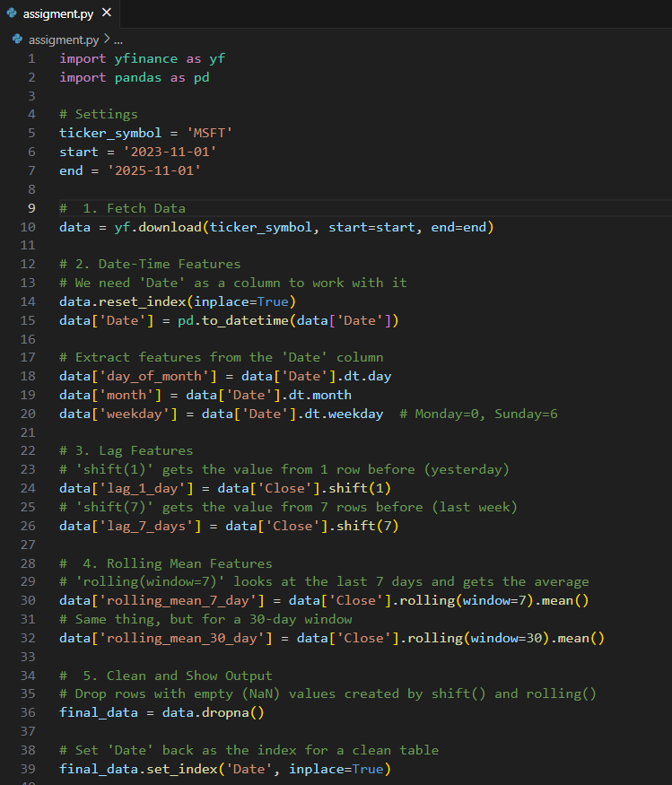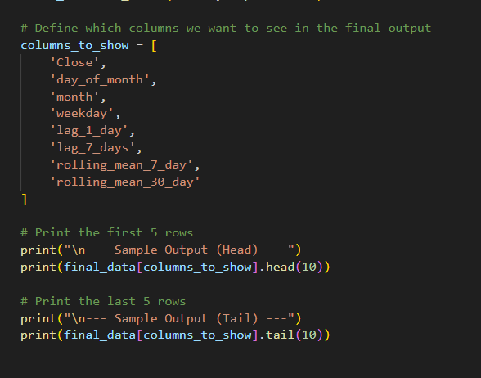
OUTPUT:-
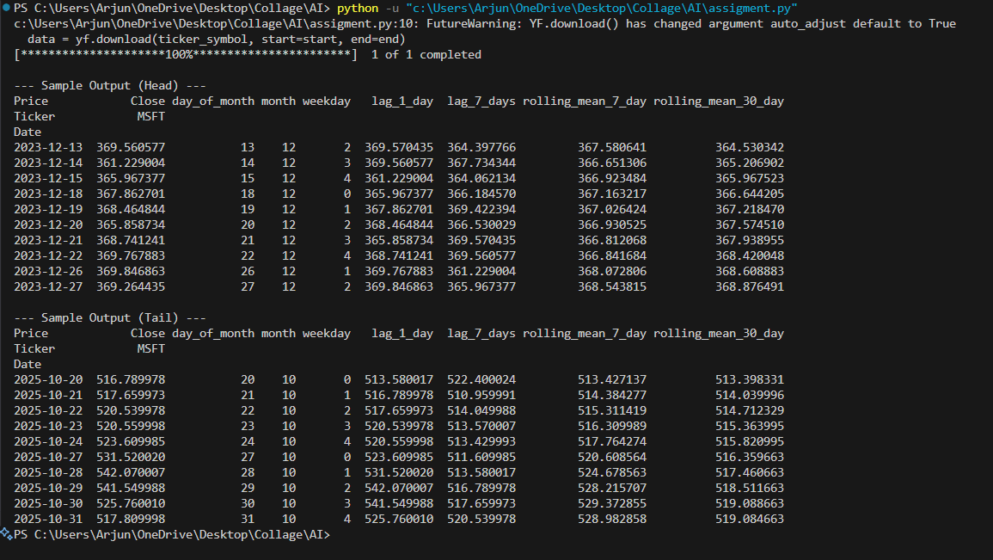

How These Features Help Find Trends
To a machine learning model, a time-series is just a list of numbers. It doesn't know what "yesterday" was or that "December" comes every year. These new features fix this by giving the model crucial context. We are essentially providing it with a calendar, a memory, and a way to see the "big picture" trend.
1. Date-Time Features (The "Calendar")
- What they do: These features break the date down into its components: day_of_month, month, and weekday.
- How they help: This allows the model to spot seasonality, or patterns that happen at regular times. For example, the model can learn if there's a "day-of-week effect" (like prices dropping on Mondays) or a "month effect" (like a holiday sales spike in November).
- Impact: The model learns to distinguish between a predictable, seasonal dip and the start of a new, negative trend. It learns not to "panic" just because it's a "slow August."

2. Lag Features (The "Memory")
- What they do: These features are the model's short-term memory. They show it exactly what the price was 1 day ago (lag_1_day) and 7 days ago (lag_7_days).
- How they help: This is all about capturing momentum. The model can directly compare the current price to the price yesterday or last week.
- Impact: The model can learn rules from this comparison. If the current price is higher than both its 1-day and 7-day lags, it's a strong signal of an upward trend. It helps the model see the difference between a single "good day" and a real "winning streak."

3. Rolling Mean (The "Smooth Trend Line")
- What they do: A daily stock chart is "noisy" with lots of spiky up-and-down movements. A rolling mean smooths out this noise by averaging the price over a set window (e.g., the last 7 or 30 days).
- How they help: They create a clean, smooth trend line for the model to follow. The rolling_mean_7_day shows the short-term trend, while the rolling_mean_30_day shows the "big picture" long-term trend.
- Impact: The model can now compare the current price to these averages. If the price is above the 30-day average, it's a clear sign of a long-term uptrend. Even better, if the short-term 7-day average crosses above the long-term 30-day average, it's a powerful signal that positive momentum is accelerating.

